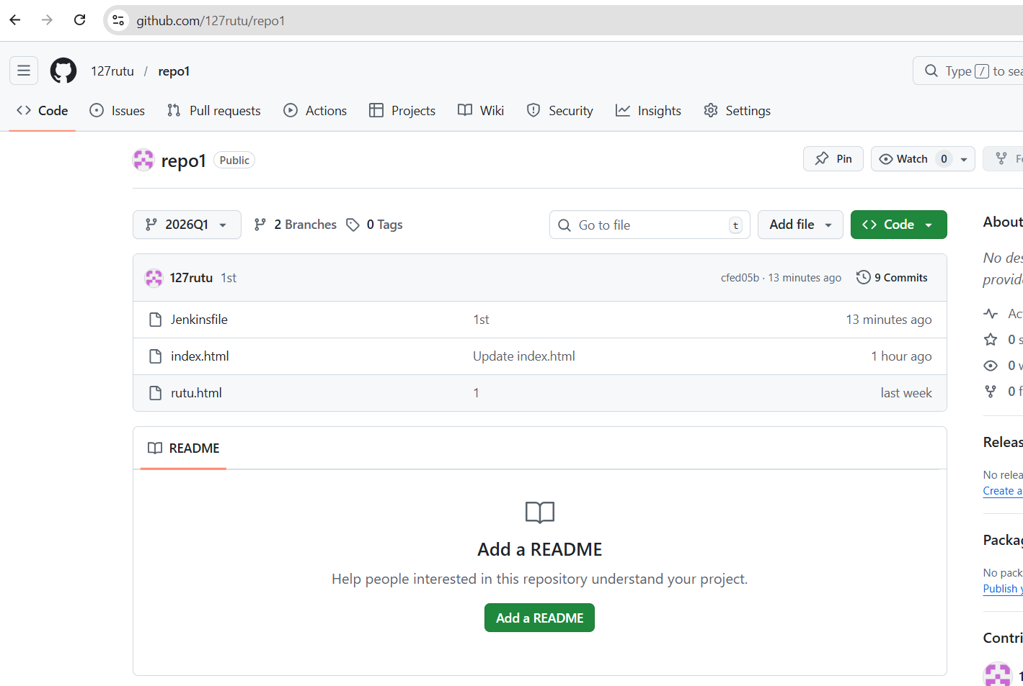
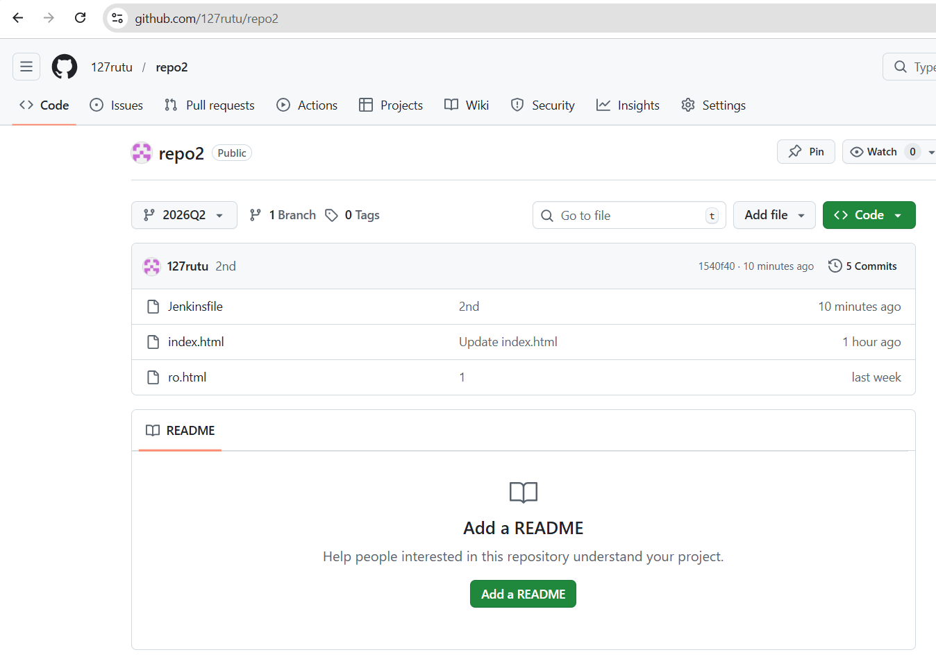
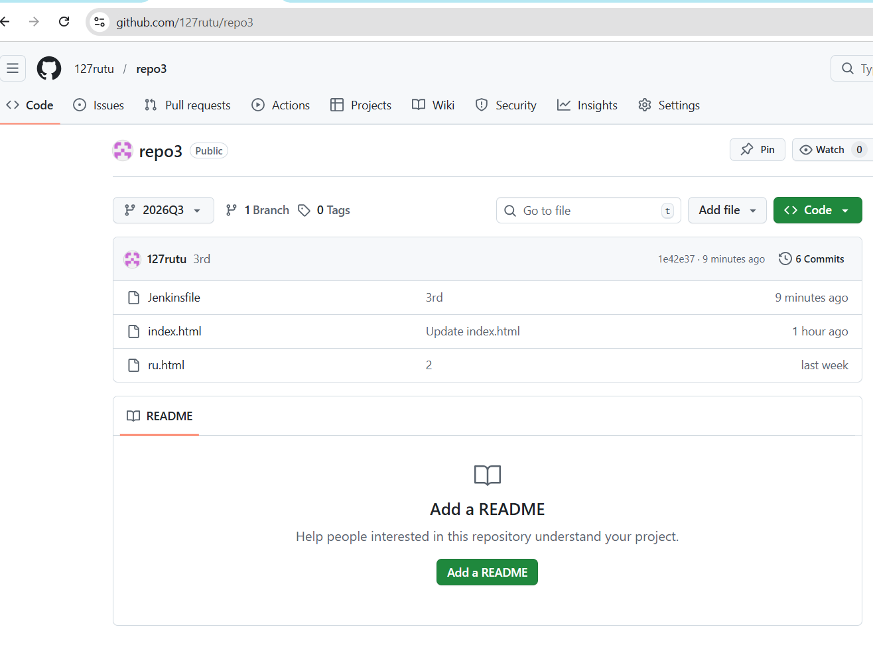
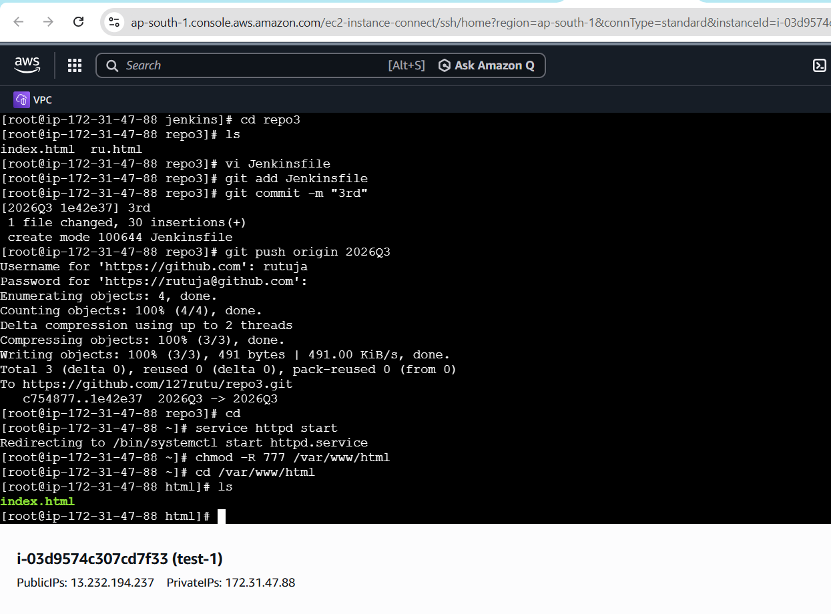
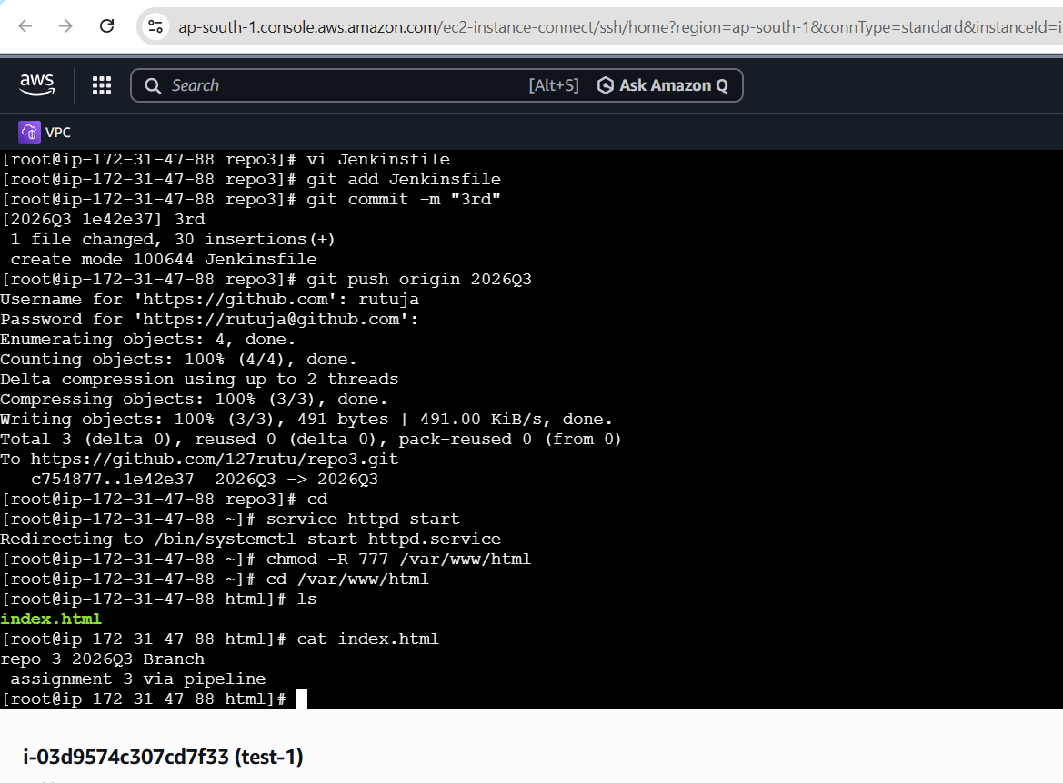
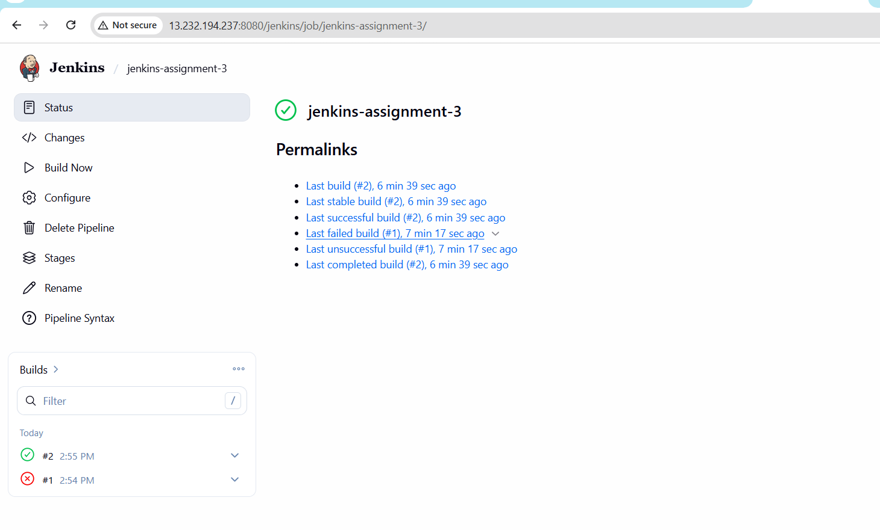
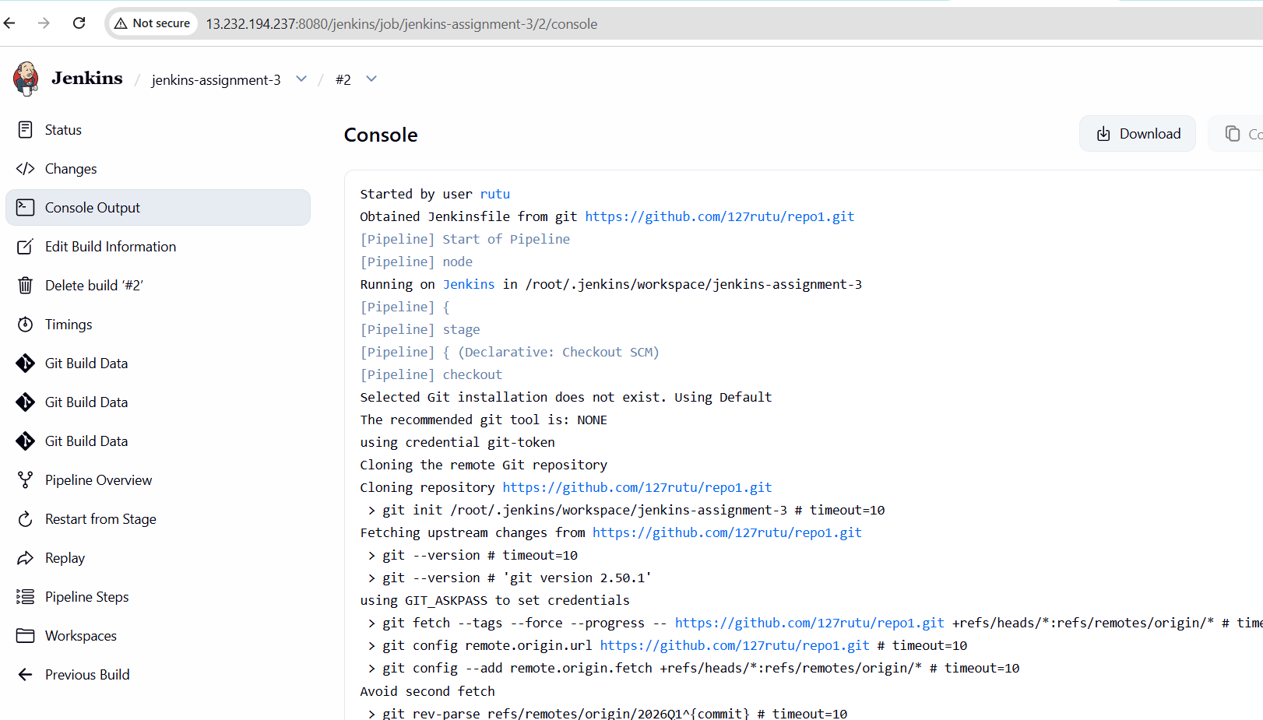
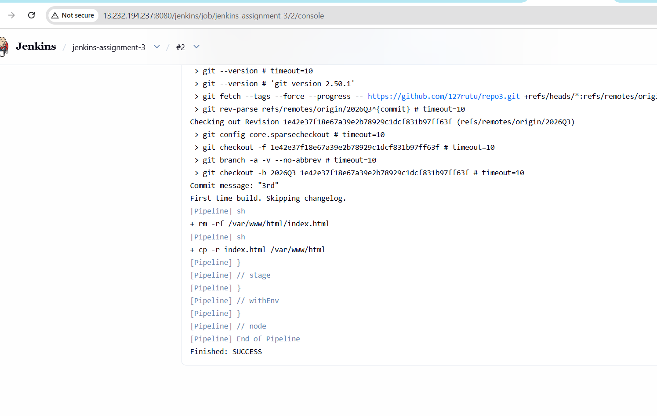
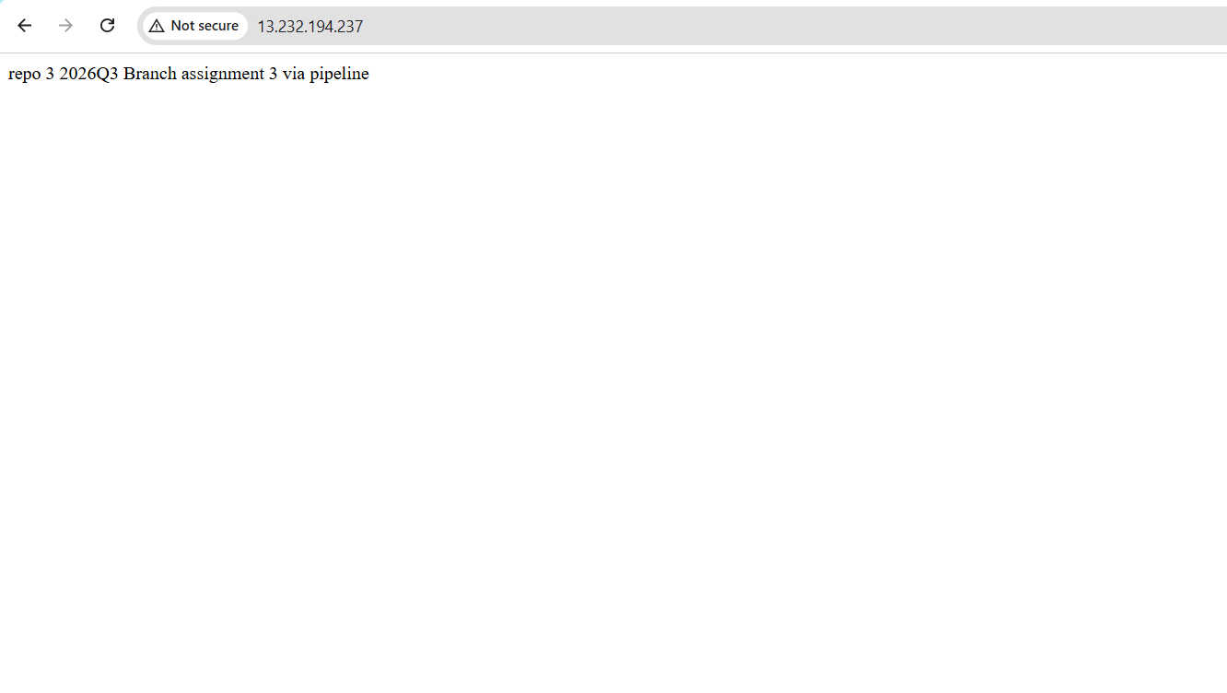
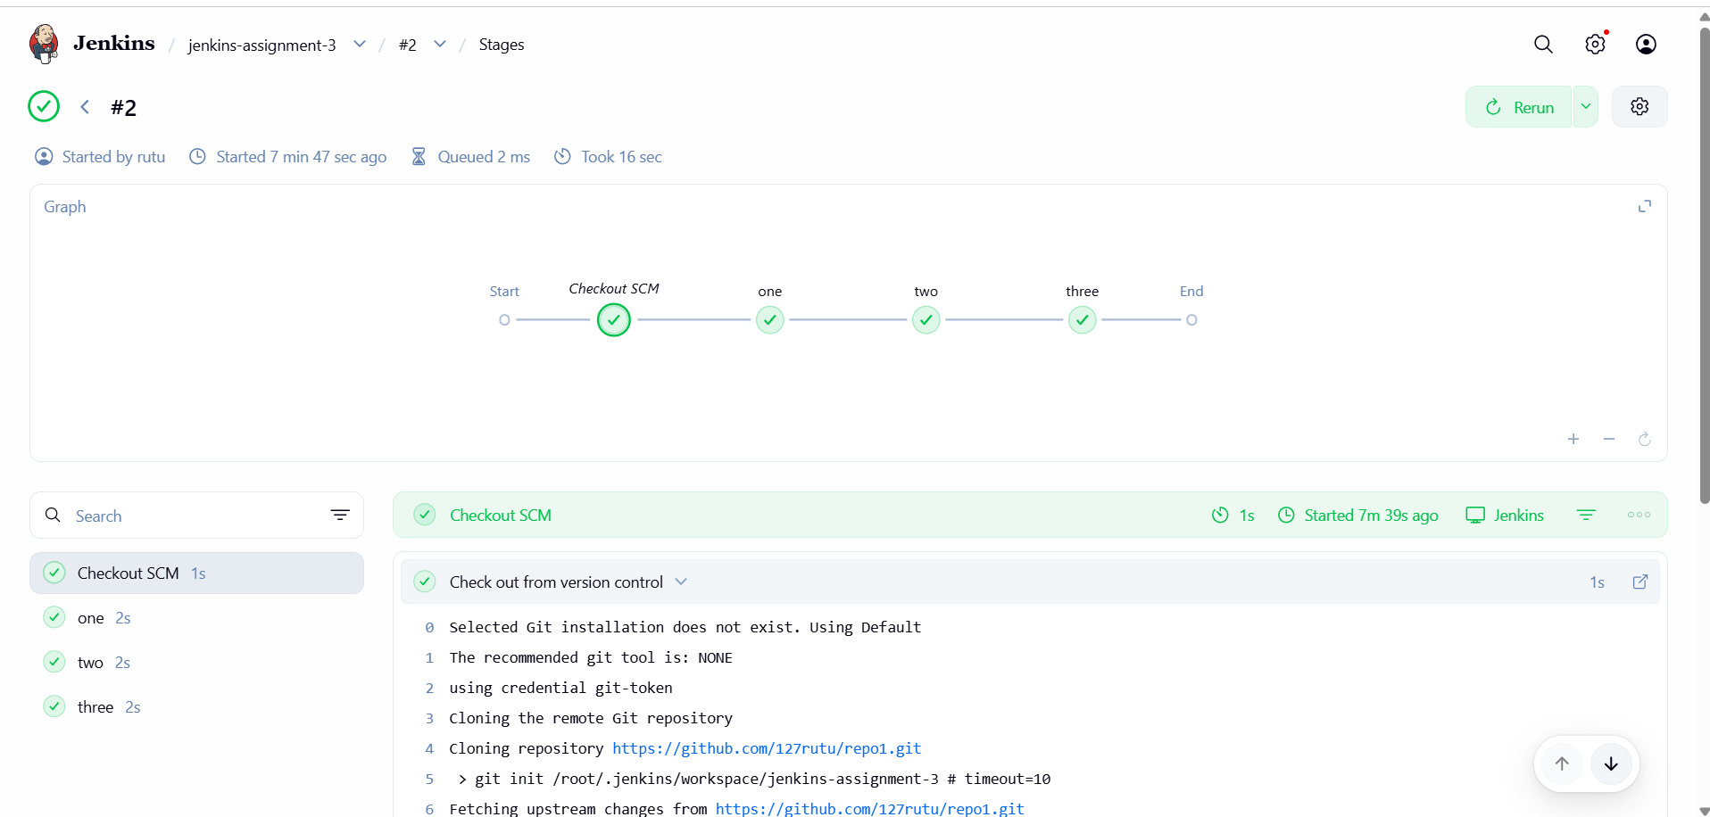
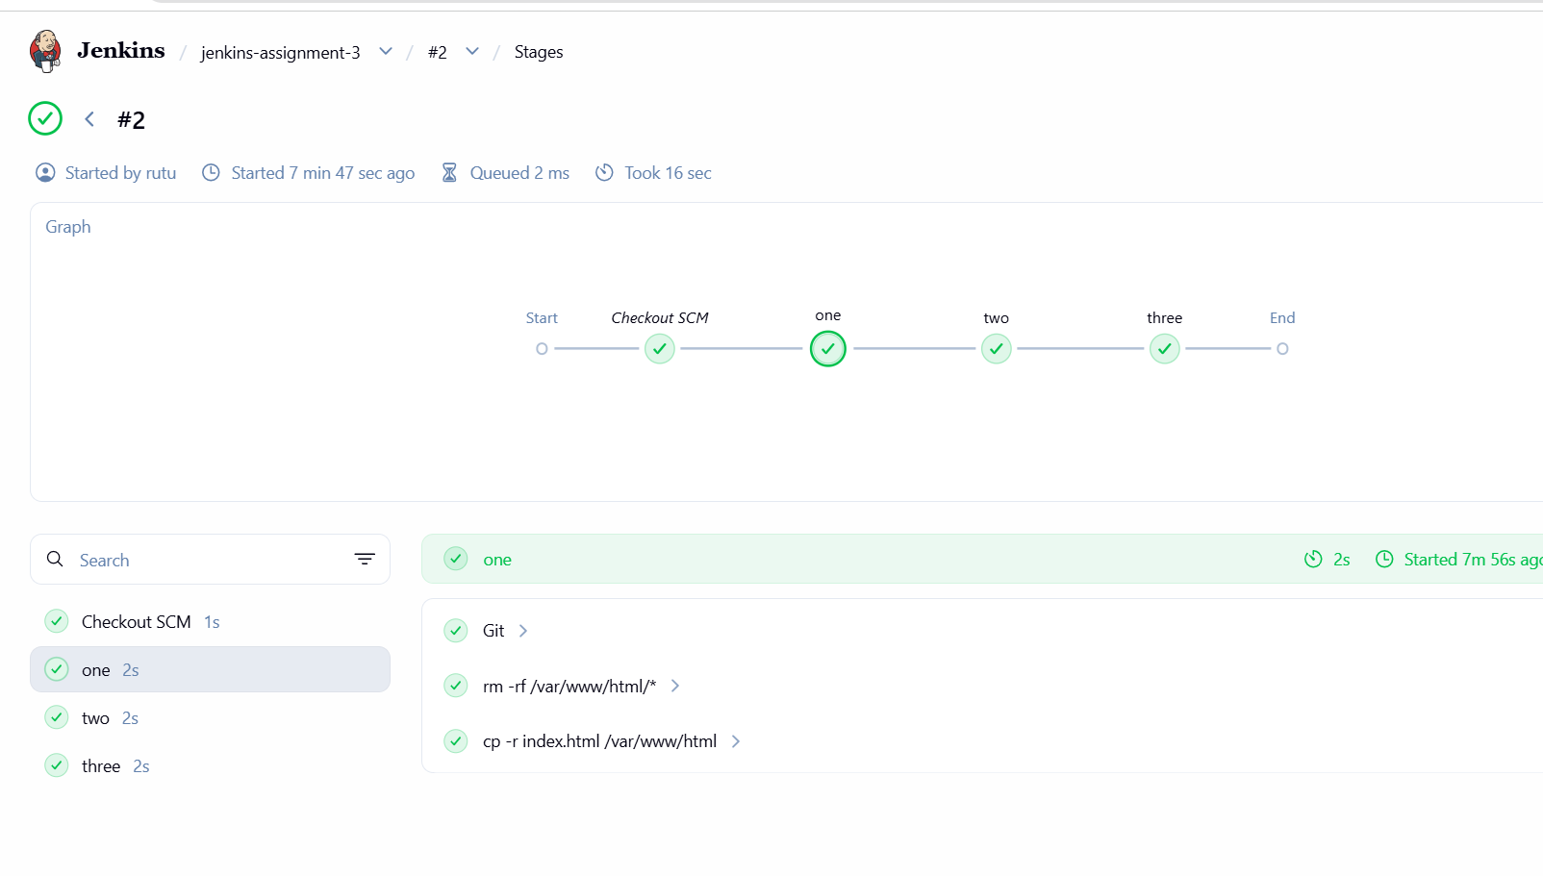
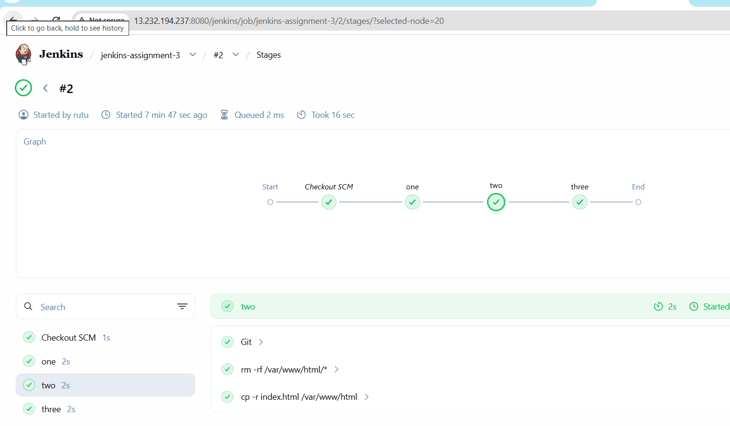
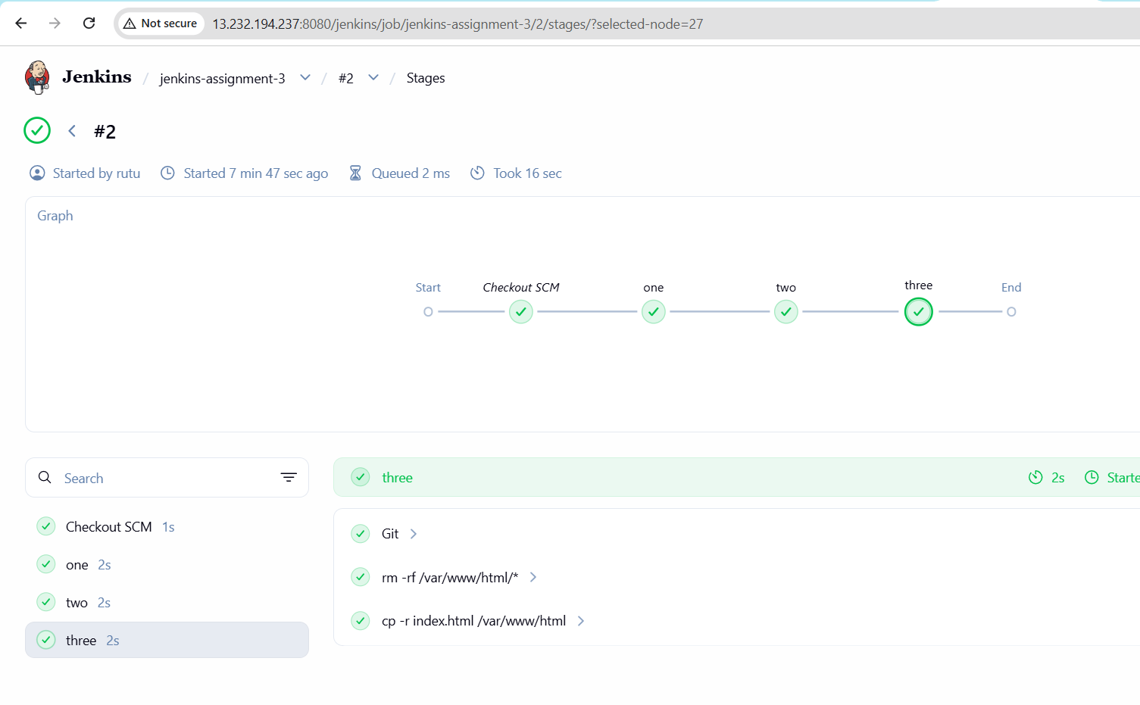

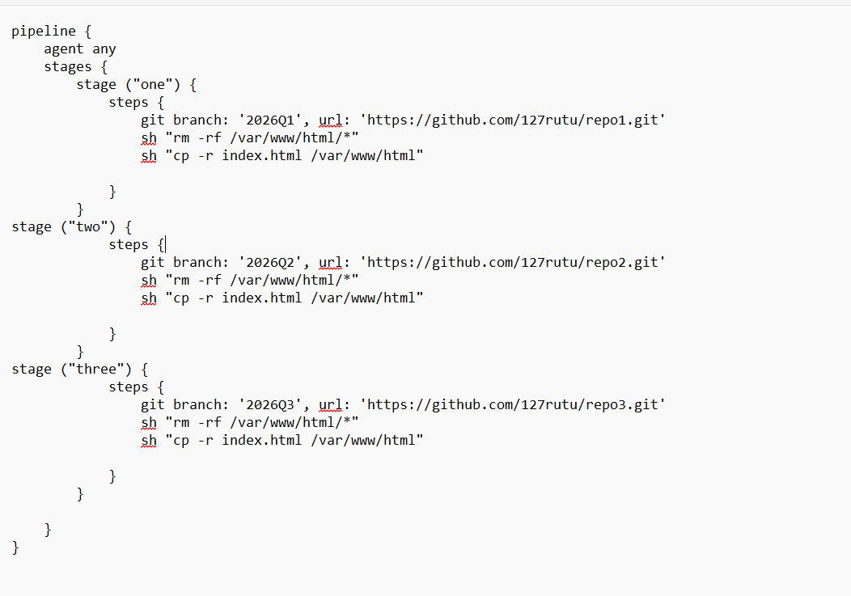

pipeline {
agent any
stages {
stage ("one") {
steps {
git branch: '2026Q1', url: 'https://github.com/127rutu/repo1.git'
sh "rm -rf /var/www/html/*"
sh "cp -r index.html /var/www/html"

}
}
stage ("two") {
steps {
git branch: '2026Q2', url: 'https://github.com/127rutu/repo2.git'
sh "rm -rf /var/www/html/*"
sh "cp -r index.html /var/www/html"

}
}
stage ("three") {
steps {
git branch: '2026Q3', url: 'https://github.com/127rutu/repo3.git'
sh "rm -rf /var/www/html/*"
sh "cp -r index.html /var/www/html"

}
}

}
}

